CAS PY 106

Pre-lecture note 10

1. Electric Power
2. Light bulbs are stamped with two numbers such as 100W and 120V
3. 100W is watts, power dissipated in the bulb
4. The electrical energy is turned mainly into thermal energy, not light, but the power is proportional to the brightness
5. Resistors, in general, turn electrical energy into thermal energy
6. Three equations

P = I \* V = I^2 \* R/ = V^2/R

1. Derived from:

P = W/t = Q \* V / t = IV

1. Understanding electric bill
2. Electric company bills you for amount of energy used each month
3. Measure in units of kilowatt-hours (kW h)
4. How many joules is 1 kW-h?

1kW h = 1000W \* 1h = 1000J/s \* (3600s) = 3.6 million joules (energy unit)

1. Electricity costs
2. Cost of running electrical device is given by:

Cost = (Power rating in kW) \* (hours the device is on) \* (cost per kW-hr)

1. We estimate $0.20 as cost per kW-hr and most devices have power rating stamped on them
2. Ex)
3. Clock radio = 5W = 0.005kW
4. Light bulbs: typically 10W-100W (0.01kW – 0.1kW)
5. Microwave oven: 1000W = 1kW
6. Hair dryer = typically 1.75kW
7. TV = 300w = 0.3kW
8. Ex) TV is on for 3 hours. If TV has power rating of 300W, daily cost is?

Cost = 0.30kW \* 3 hours \* 0.20 per kW-hr = 0.18 = 18 cents

1. Resistors in parallel
2. When resistors are arranged in parallel, the current has multiple paths to take
3. Potential difference across each resistor is the same, and the currents add to equal the total current entering the parallel combination
4. 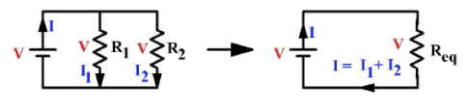

I = I1 + I2

V/R = V/R1 + V/R2

1. The V’s are all the same, and we can generalize to any number of resistors, so the equivalent resistance of resistors in parallel is:

1/R = 1/R1 + 1/R2 +…

1. Resistors in Series
2. When resistors are in series, they are arranged in chain, so the current has only one path to take – the current is the same through each resistor
3. The sum of the potential differences across each resistor equals the total potential difference across the whole chain
4. 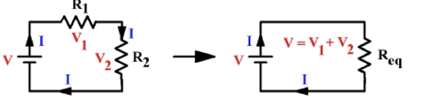

V = V1 + V2

IR = IR1 + IR2

1. The I’s are the same, and we can generalize to any number of resistors, so the equivalent resistance of resistors in series is

R = R1 + R2 + …

1. For example, we have resistors connected in series such as figure below
2. 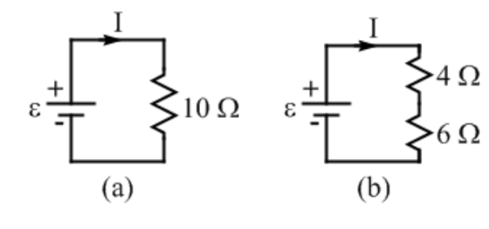
3. Figure b has two resistors, 4 and 6
4. The battery sees no difference between the single 10 resistor and 4&6 resistors that are connected in series- the battery is still trying to force charge to flow through a total resistance of 10